* Provide example of “nothing” in the tutorial
  + - Added 2 examples of ambient ocean noise in both the regular and screen-reader tutorials
* Provide multiple examples of nothing in the field guide
  + - Added “Ambient Ocean Noise” category to field guide, with 7 examples
* Provide more examples of ships and humpbacks in the field guide
  + - Added 4 more examples of humpbacks and 5 more of ships
* Add instruction to the multiple choice selections that users can include notes of other sounds they may have heard in the “Talk” page
  + - Added comment to tutorial “Feel free to add comments about different or unusual sounds by selecting "Done & Talk".”
* Use consistent max volume across all clips in tutorial, field guide, and workflow
  + - All our clips were normalized to 5 dB less than the max volume
* Add note to use headphones
  + - * Edited “Help Text” for workflow:
        + Are you having trouble identifying the sounds? We recommend using headphones to listen to these sounds, if available. Please take time to review the field guide as you make your decisions. That's where we provide example sounds and spectrograms from whales, ships, and ambient ocean noise that may help you.
      * Added note to tutorial
        + “We recommend using headphones to listen to these sounds, if available.”
* Include a map of all drifts on “Research” Page - include a note on workflow description stating which drift the data came from
* Ask Zooniverse developers to
  + adjust position of scrolling lines
  + Add option to play sound at different speeds (option available in Hawk Talk)
  + Fix ghosted images on ‘Recent’

Working with labeled data

Resolve multiple selections

Eliminate cases where multiple labels were selected, including ‘none of the above’ (can’t have something and nothing!)

Remap: humpbacks + ships to ‘humpbacks and ships’

Eliminate option to have multiple selections in the tutorial

Resolve inconsistent labels in workflows

1. Humpback whales
2. Ship noise
3. Humpback whales and ship noise
4. None of the above

Prediction = Beta-tester labels

Reference = Anne’s labels

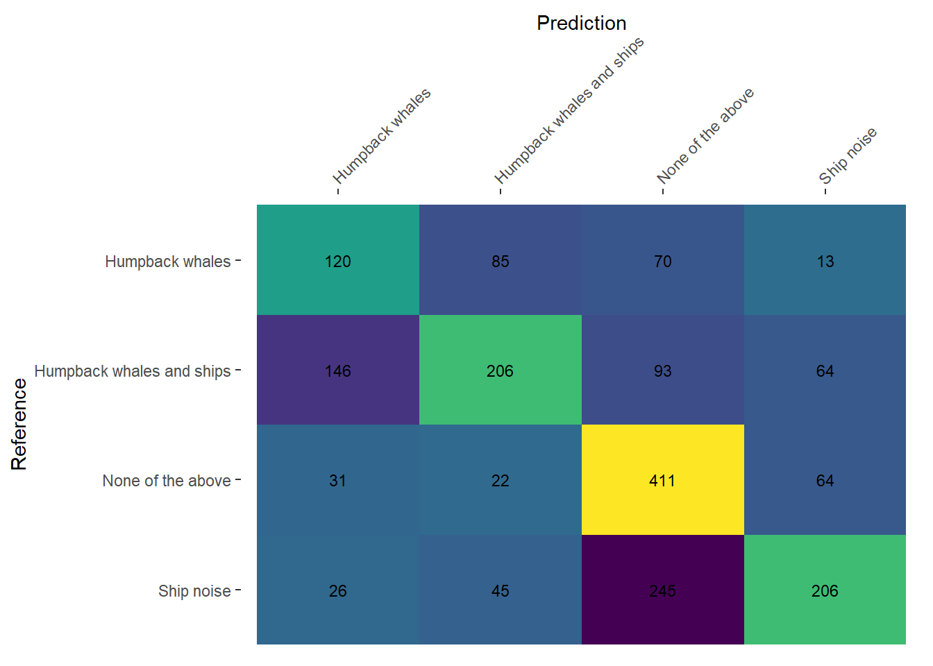

The most common source of confusion was assigning clips with ‘none of the above’ to the ‘ship’ category.

We might want to re-think the normalization of clips, since ‘ambient’ noise clips are artificially similarly loud as ship noise.

If we can clear up the ship/none of the above confusion, then we likely can correct the 85 humpback clips that were labeled as humpback whales & ships.

* Add notes to the tutorial to watch for horizontal lines or clear impulses from ship noise
* Add notes to field guide that ambient noise will lack horizontal lines or impulses
* Add notes to field guide that ship noise should have horizontal lines or clear impulses
* Add reminder to multiple choice to label based on clearest choice, with reference to field guide for examples.

Can we require participants to get a minimum correct score on a training dataset before moving forward?